**ACKNOWLEDGEMENT**

We are grateful to our project mentor **Mr. Parimal Trivedi** for the guidance, inspiration and constructive suggestions that helpful us in the preparation of this project.

We feel honored to work under his guidance. The successful completion of **“Library Management System”** project is due to his help and support with needful guidance to us.

Last but not least, we would like to thank **Indus  University** for providing us with this project, which will  undoubtedly improve our knowledge and abilities.

**INTRODUCTION**

A project called a library management system organizes and electronically maintains book information for use by students.

The approach makes it easier for students and the librarian to maintain a continuous inventory of all the books available in the library.

The need to continuously monitor the books supplied and returned and even determine fines arises.

It is simple to add new members or terminate existing memberships. Manually performing this task will be laborious and prone to error.

By allowing the system to maintain track of information such as issue date, final date to return the book, and even fine information, it is not necessary to manually keep track of this information, which reduces the likelihood of errors.

Hence, by eliminating the possibility of detail errors, this method greatly lowers human effort and allows the activities of the library to proceed without interruption.

**ORGANIZATION PROFILE**

1. **SCOPE OF THE PROJECT :-** 
   * "Library Management System" is the software used to record transactions that take place in library.
   * It does away with the library's time-consuming manual system.
   * It offers features including the ability to keep record of books that have been issued and more.
   * Updates the software application that replaces the manual library system.
   * Reduces paperwork and offers data security while providing facilities for effective monitoring.
   * All administrators, librarians, and students will have access to all details with only a click.
2. **TOOLS AND TECHNOLOGY :-**

The following software and tools are used on the website:

1. For Front-end Desgin

* + HTML
  + BOOTSTRAP
  + JAVASCRIPT

2.For back-end

* + PHP

3.For database

* + MySQL

4.For presentation

* + Draw.io
  + Canva

1. **MODULES AND USERS:-**

STUDENTS:-

* + Login
  + Profile
  + Total Books
  + Borrowed Books
  + Fines
  + Logout

LIBRARIAN:-

* + Login
  + Profile
  + Total Books
  + Students
  + Borrowed books
  + Fines
  + Logout

ADMIN:-

* + Login
  + Books
  + Category
  + Librarian
  + Logout

**EXISTING SYSTEM**

Early days Libraries are managed manually. It required lot of time to record or to retrieve the details. The employees who have to record the details must perform their job very carefully. Even a small mistake would create a lot of problems. Security of information is very less. Report generations of all the information is very tough task.

All book transactions in our current system are carried out manually, which adds to the processing time for operations like borrowing and returning books as well as looking up members and books. Another significant drawback is that it will take longer to prepare the list of books that have been borrowed and those that are still available in the library; at the moment, this process takes a full day to verify all information. Therefore, after conducting a feasibility analysis, we decided to computerise the manual library administration system.

**NEED OF THE SYSTEM**

A library management software used by librarian to track all of the books, issue books rapidly, and do other tasks.

These are some reasons why a library management system is necessary:-

* Time-saving
* Cost-effective
* Safety
* Maintain data
* Both ends find it easier to use
* Reduces Operating Cost

“Makes Your Library A Smart Library”

**PROPOSED SYSTEM**

Proposed system is an automated Library Management System. Through our system :-

**Student** can view profile, view books on basis of categories, borrow book and view borrow book and penalty for late handing of books.

**Librarian** can view profile, add students, view books on basis of categories, view students details, borrowed history and penalty history.

**Admin** can view profile, add librarian, add books on basis of categories

Advantages:-

* User friendly interface
* Fast access to database
* Less error
* More Storage Capacity
* Look and Feel Environment
* Quick Transaction

**SYSTEM FLOW DIAGRAM**

**STUDENTS: -**

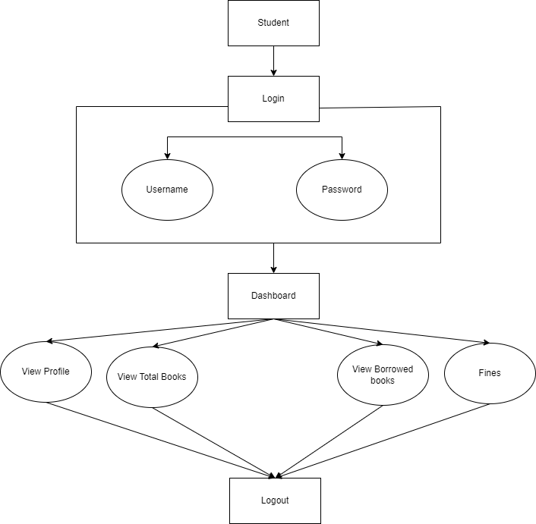

**LIBRARIAN: -**

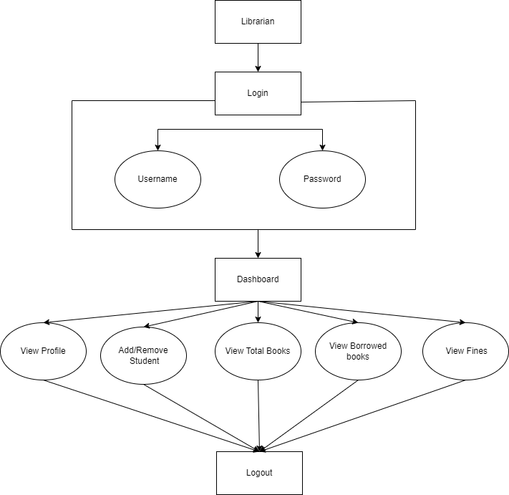

**ADMIN: -**

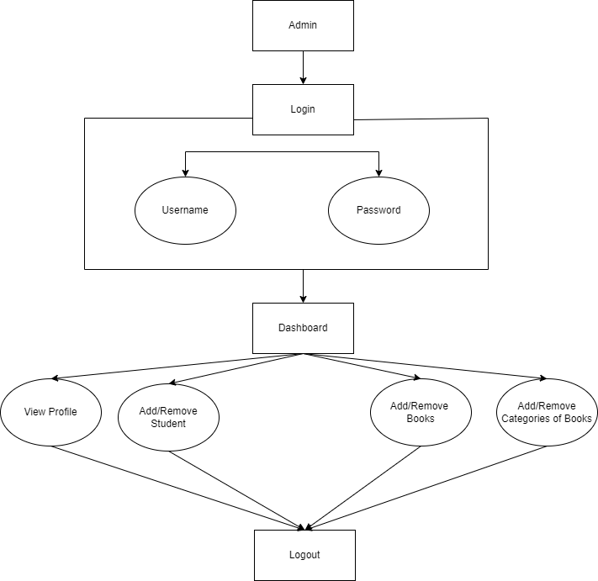

**UML DIAGRAMS: -**

**USE CASE DIAGRAM: -**

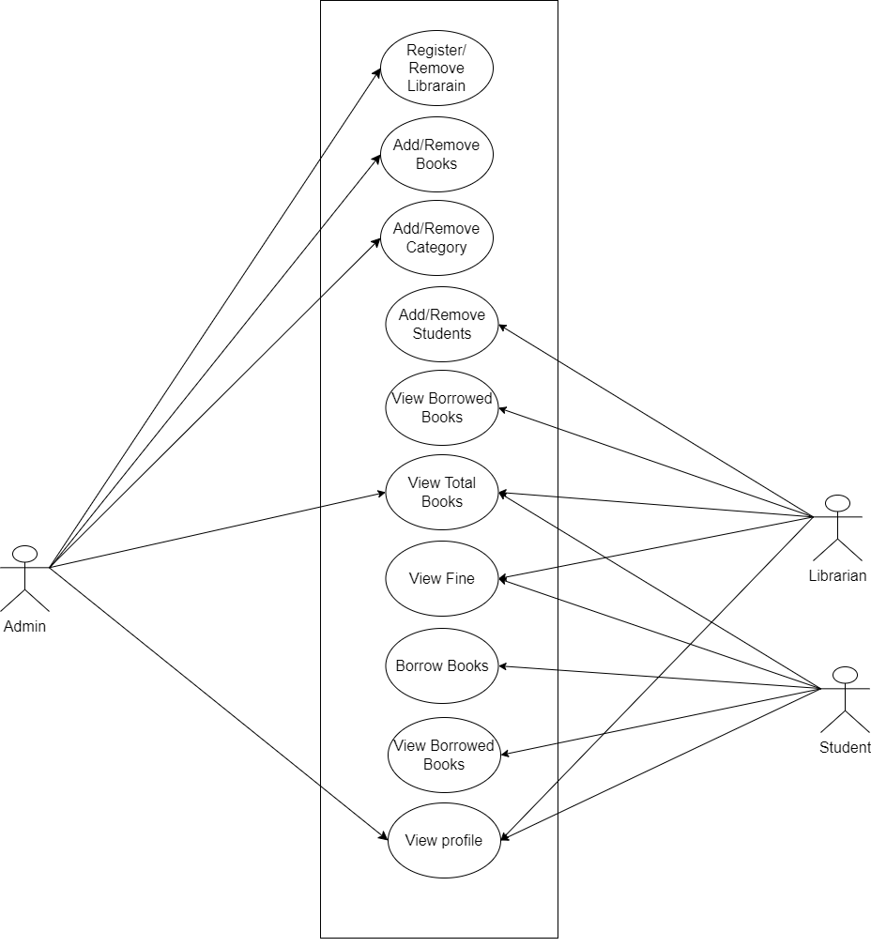

**ACTIVITY DIAGRAM FOR STUDENTS: -**

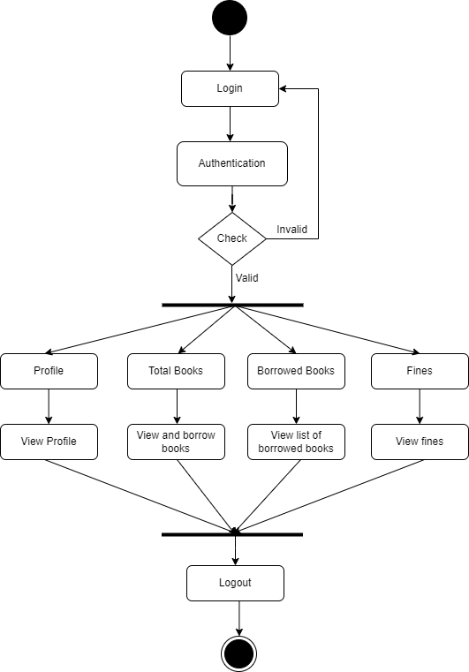

**ACTIVITY DIAGRAM FOR LIBRARIAN: -**

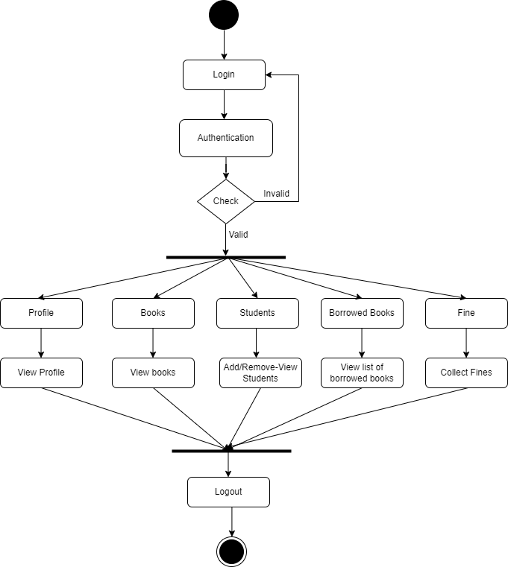

**ACTIVITY DIAGRAM FOR ADMIN: -**

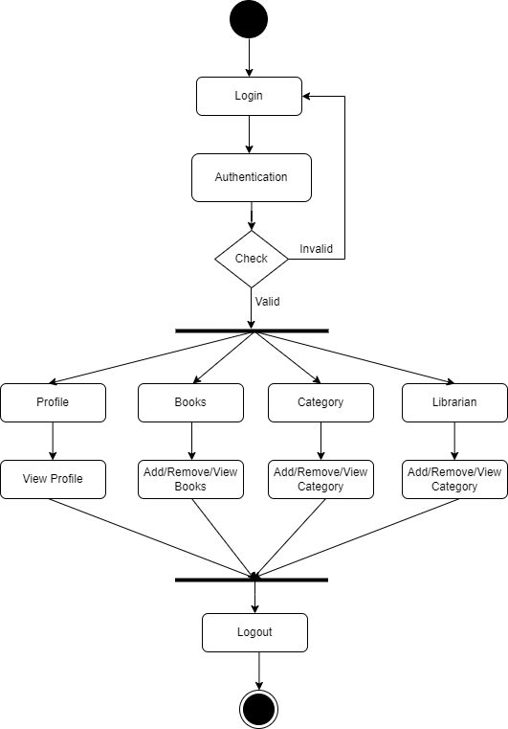

**CLASS DIAGRAM: -**

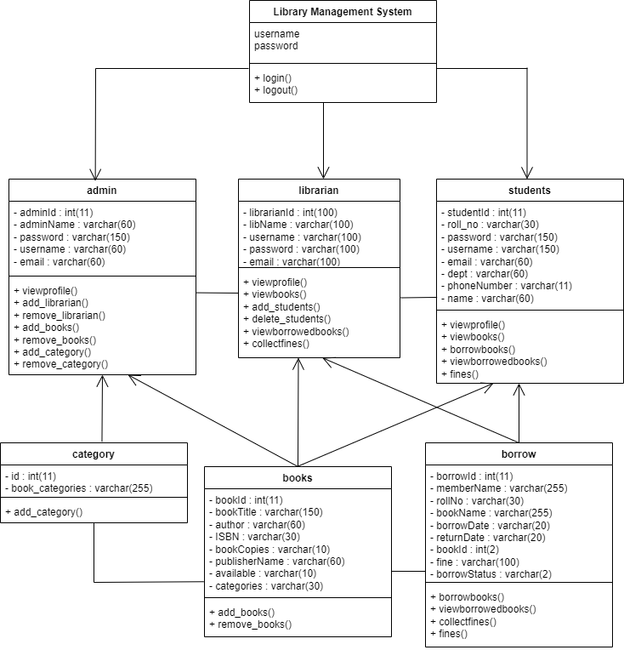

**DATA DICTIONARY**

**MASTER TABLE: -**

**ADMIN: -**

|  |  |  |  |  |
| --- | --- | --- | --- | --- |
| **Sr.No** | **Field Name** | **Datatype-Size** | **Constraints** | **Description** |
| 1 | adminId | int(11) | Primary key | Id Of Admin |
| 2 | adminName | varchar(60) | Not null | Name of Admin |
| 3 | password | varchar(150) | Not Null | Password of Admin |
| 4 | username | varchar(60) | Not null | Username of Admin |
| 5 | email | varchar(60) | Not null | Email of Admin |

**BOOKS: -**

|  |  |  |  |  |
| --- | --- | --- | --- | --- |
| **Sr.No** | **Field Name** | **Datatype-size** | **Constraints** | **Description** |
| 1 | bookid | int(11) | Primary key | Id of Book |
| 2 | bookTitle | varchar(150) | Not null | Title of Book |
| 3 | author | varchar(60) | Not null | Author of Book |
| 4 | ISBN | varchar(30) | Not null | ISBN of Book |
| 5 | bookCopies | varchar(10) | Not null | Number of copies of Book |
| 6 | publisherName | varchar(60) | Not null | Publisher of Book |
| 7 | available | varchar(10) | Not null | Availablilty of Book |
| 8 | categories | varchar(30) | Not null | Categories of Book |

**BORROW: -**

|  |  |  |  |  |
| --- | --- | --- | --- | --- |
| **Sr.No** | **Field Name** | **Datatype-size** | **Constraints** | **Description** |
| 1 | borrowld | int(11) | Primary key | Id of Borrowed student |
| 2 | mamberName | varchar(255) | Not null | Name of member who have borrowed book |
| 3 | rollNo | varchar(30) | Not null | Roll No of member who have borrowed book |
| 4 | bookName | varchar(255) | Not null | book name which is issued by the member |
| 5 | borrowDate | varchar(20) | Not null | Date of Borrowed book |
| 6 | returnDate | varchar(20) | Not null | Date of Returning Borrowed book |
| 7 | bookId | int(2) | Not null | Book id which the member have issued /borrowed |
| 8 | fine | varchar(100) | Not null | Calculation of fine on late handing to librarian |

**LIBRARIAN: -**

|  |  |  |  |  |
| --- | --- | --- | --- | --- |
| **Sr.No** | **Field Name** | **Datatype-Size** | **Constraints** | **Description** |
| 1 | librarianid | int(100) | Primary key | Id Of Librarian |
| 2 | libName | varchar(100) | Not null | Name of Librarian |
| 3 | username | varchar(100) | Not Null | Username of librarian |
| 4 | password | varchar(100) | Not null | Password of librarian |
| 5 | email | varchar(100) | Not null | Email of Librarian |

**STUDENTS: -**

|  |  |  |  |  |
| --- | --- | --- | --- | --- |
| **Sr.No** | **Field Name** | **Datatype-size** | **Constraints** | **Description** |
| 1 | studentId | int(11) | Primary key | Id of Student |
| 2 | roll_no | varchar(30) | Not null | Roll Number of Student |
| 3 | password | varchar(150) | Not null | Password of Student |
| 4 | username | varchar(150) | Not null | Username of Student |
| 5 | email | varchar(60) | Not null | Email of Student |
| 6 | dept | varchar(60) | Not null | Department of Student |
| 7 | phoneNumber | varchar(11) | Not null | Phone number of student |
| 8 | name | varchar(60) | Not null | Name of student |

**CATEGORY: -**

|  |  |  |  |  |
| --- | --- | --- | --- | --- |
| **Sr.No** | **Field Name** | **Datatype-Size** | **Constraints** | **Description** |
| 1 | id | int(11) | Primary key | Id Of Category |
| 2 | book_categories | varchar(255) | Not null | Name of category |

**USER INTERFACE SCREENS: -**

**INDEX PAGE: -**

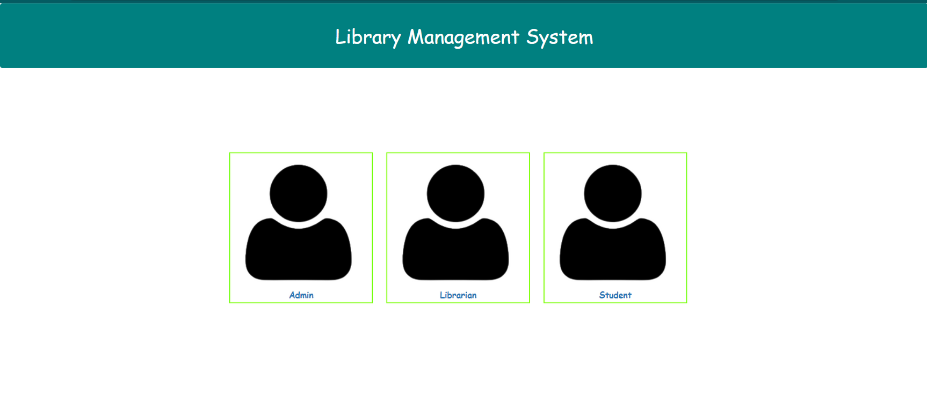

**ADMIN LOGIN PAGE**

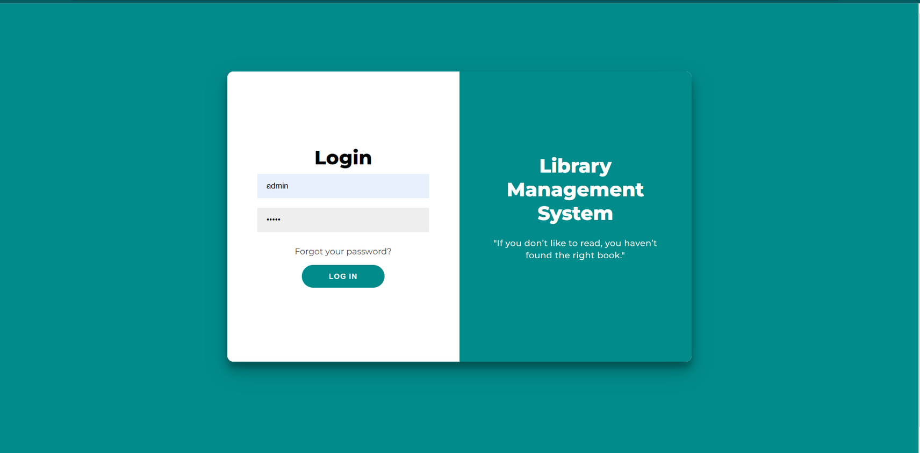

**ADMIN DASHBOARD PAGE**

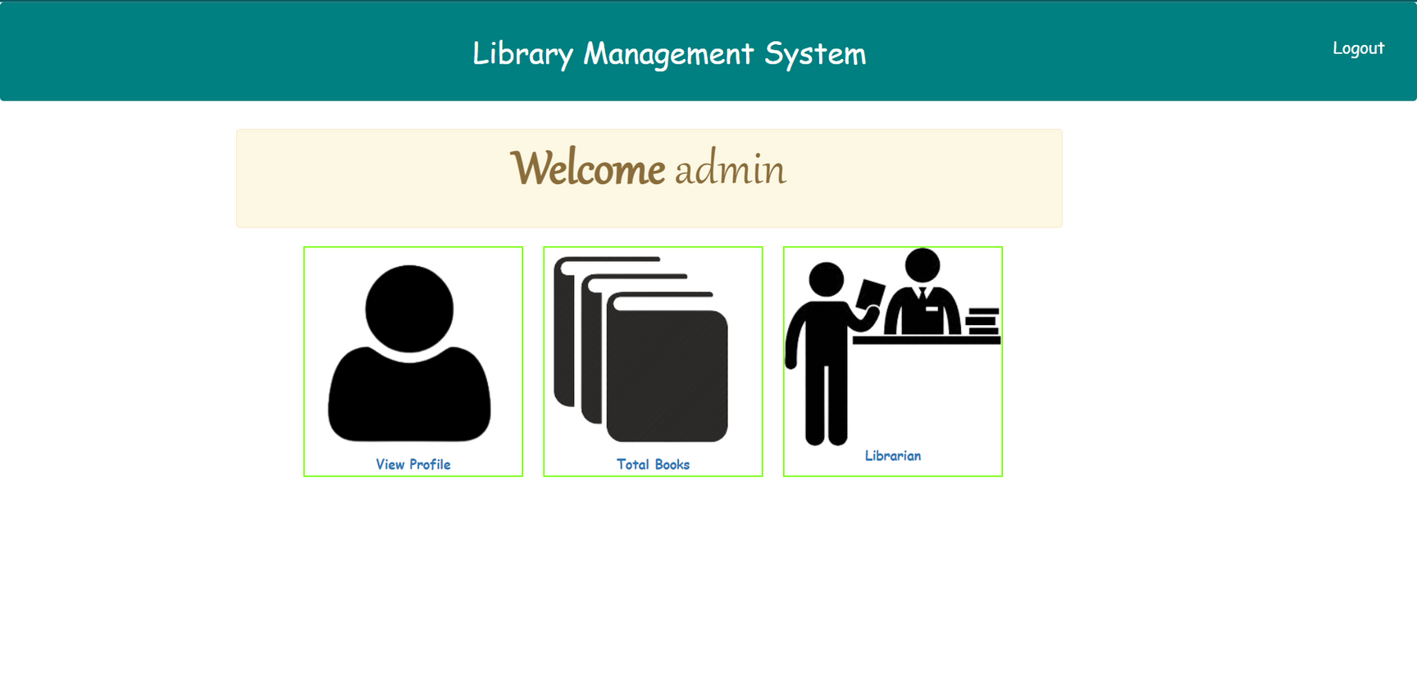

**ADMIN PROFILE PAGE:-**

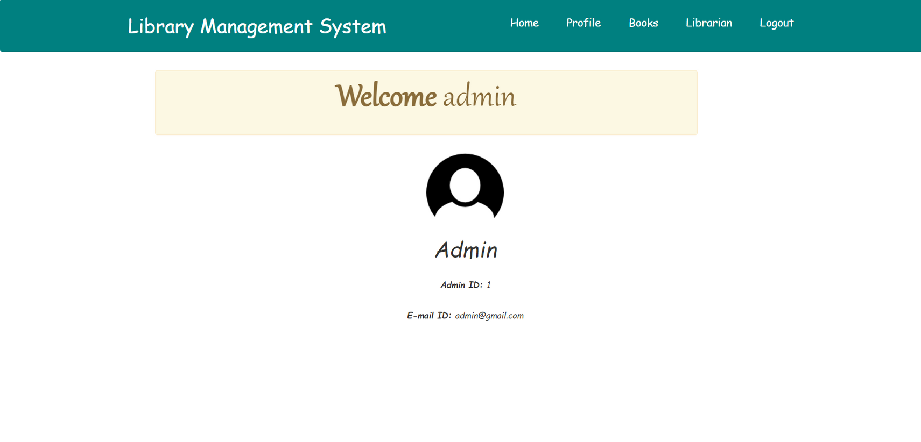

**ADMIN SIDE BOOKS PAGE**

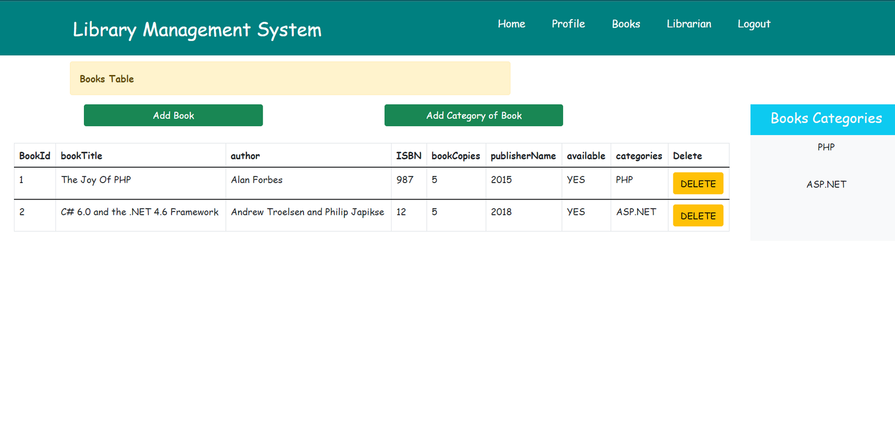

**ADMIN SIDE ADD BOOKS PAGE**

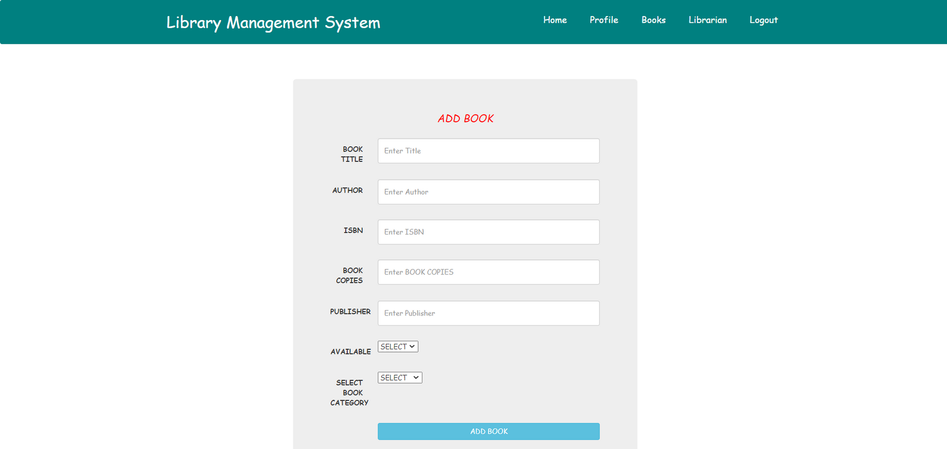

**ADMIN SIDE ADD CATEGORY PAGE**

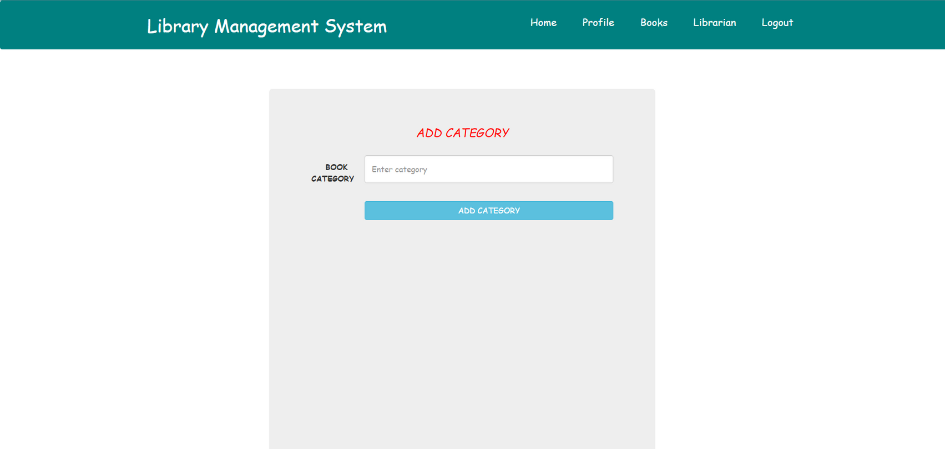

**ADMIN SIDE LIBRARIAN PAGE**

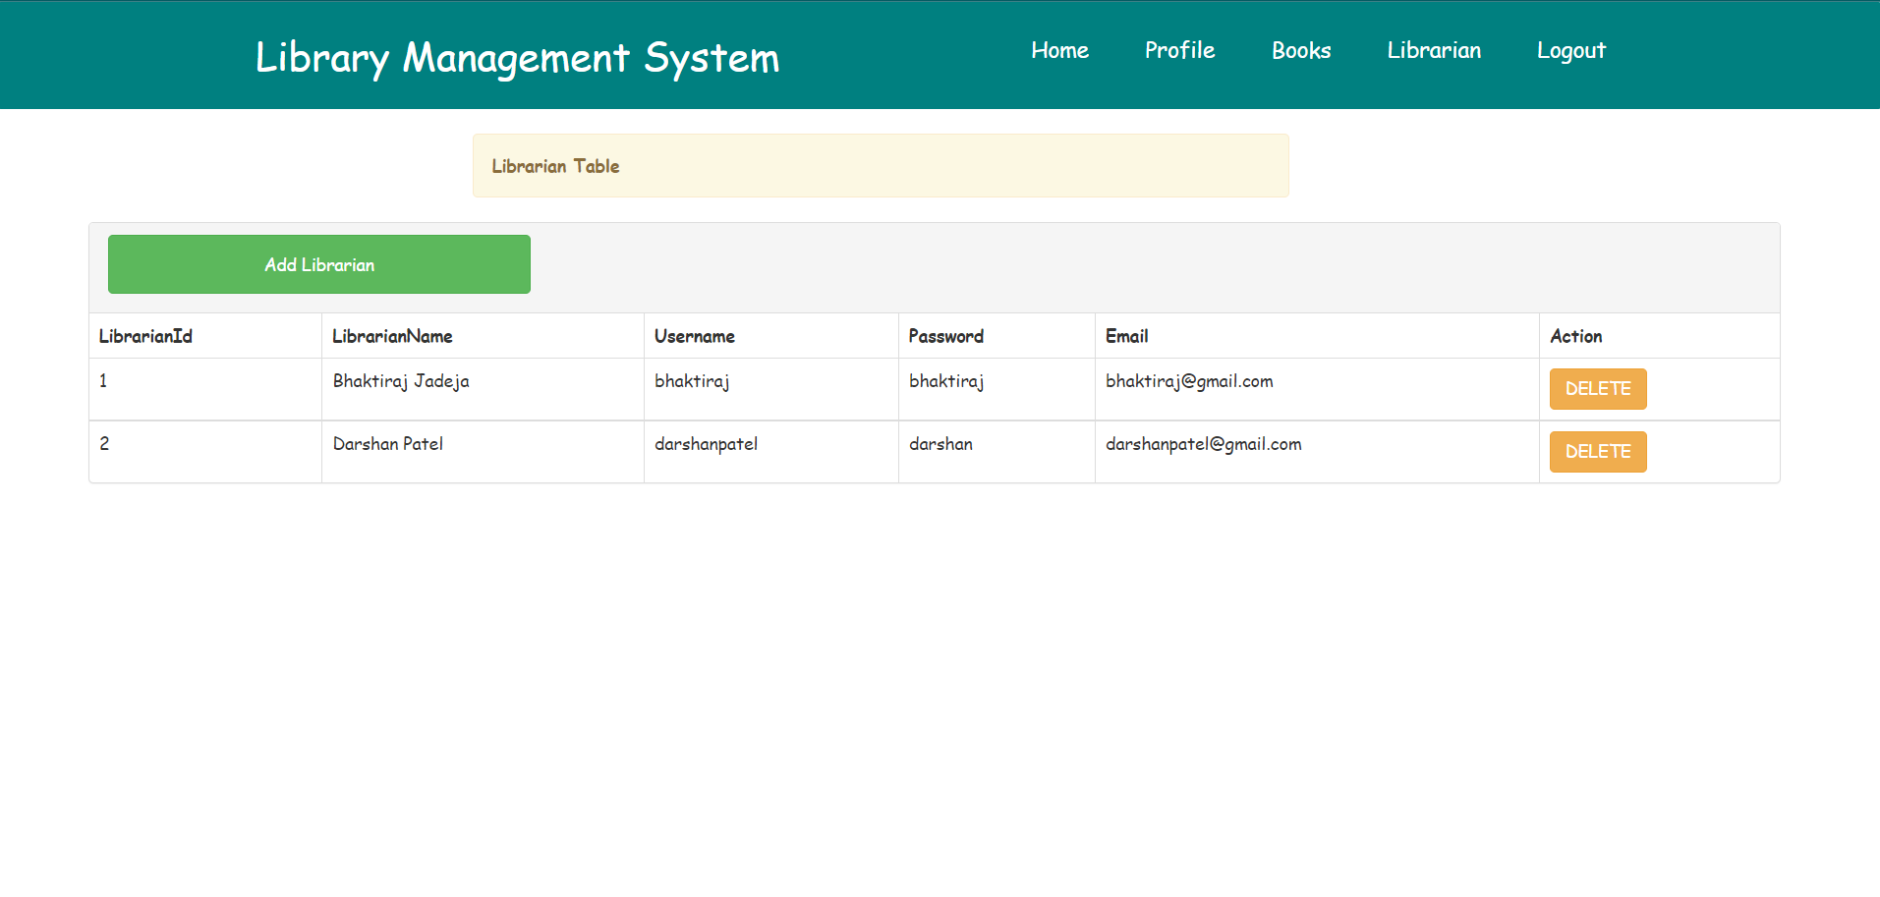

**ADMIN SIDE ADD LIBRARIAN PAGE**

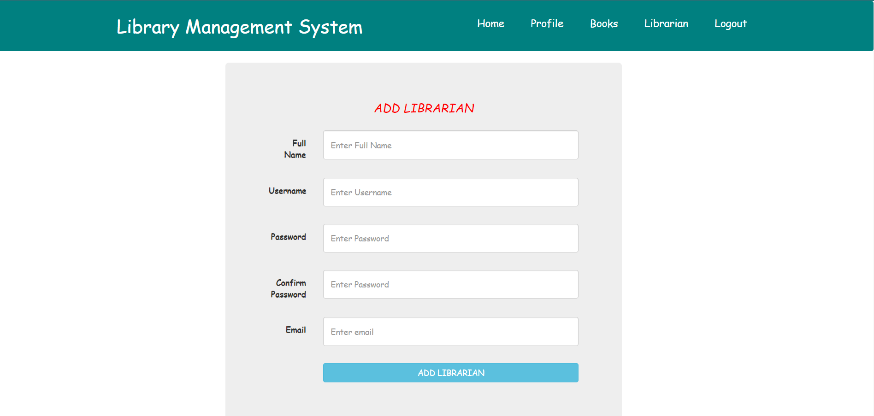

**LIBRARIAN LOGIN PAGE**

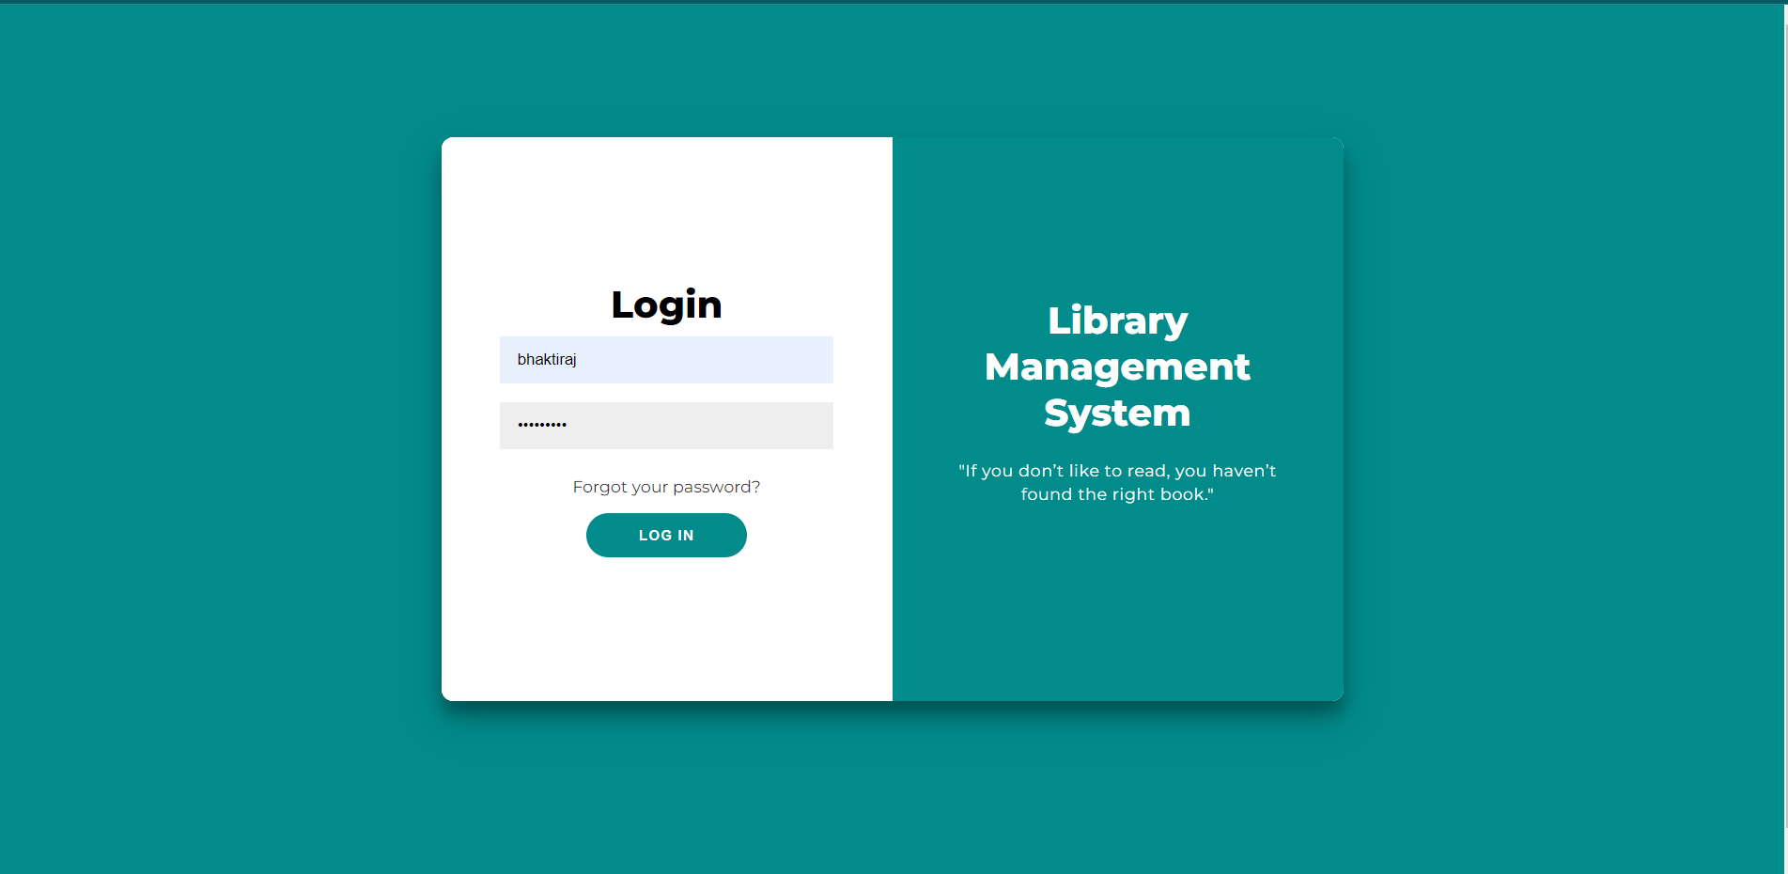

**LIBRARIAN DASHBOARD PAGE**

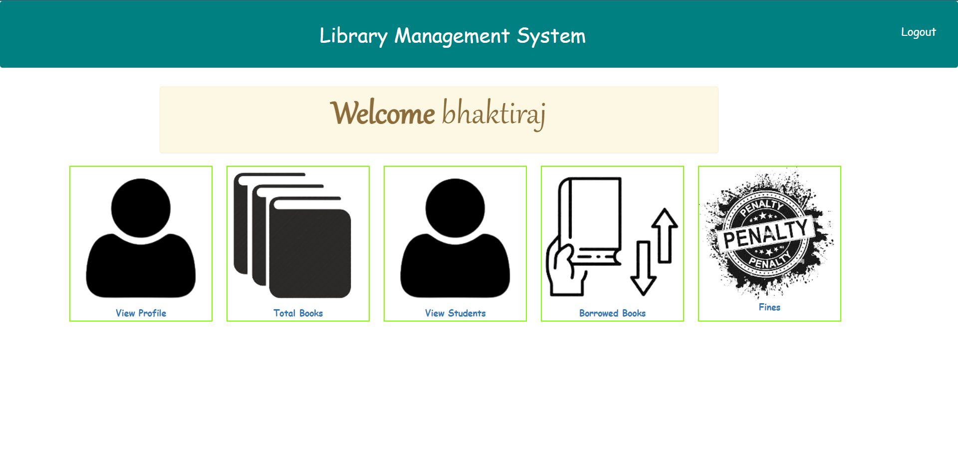

**LIBRARIAN SIDE PROFILE PAGE**

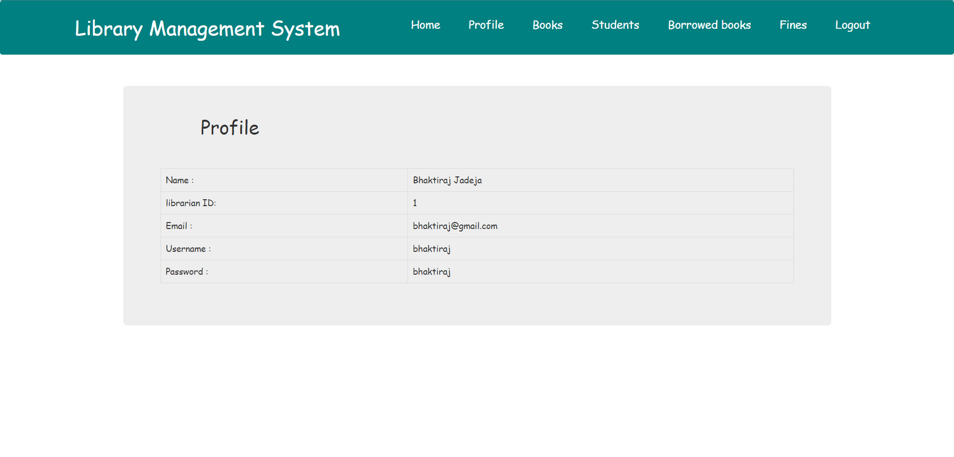

**LIBRARIAN SIDE VIEW BOOKS PAGE**

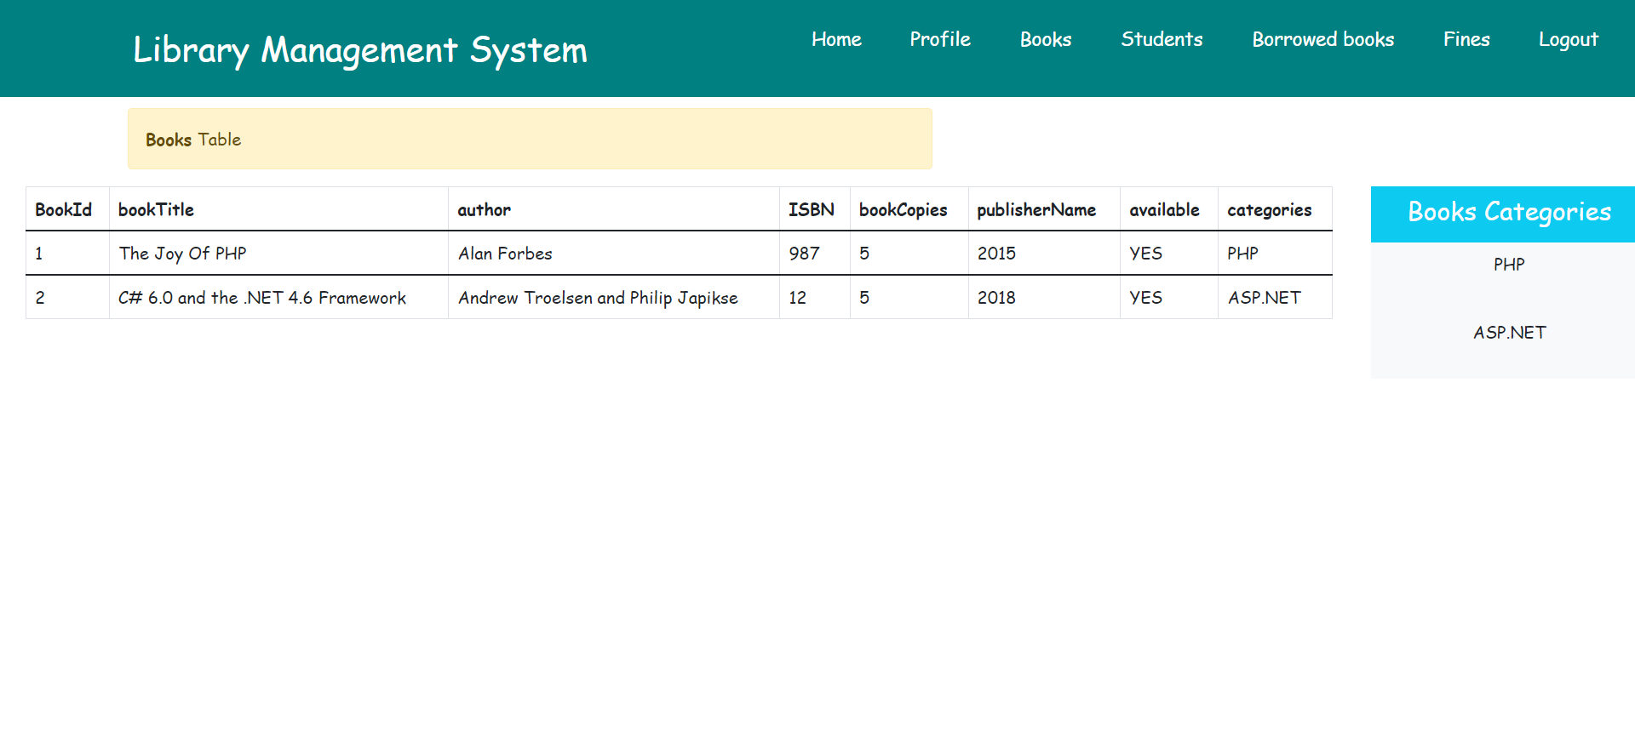

**LIBRARIAN SIDE STUDENT PAGE**

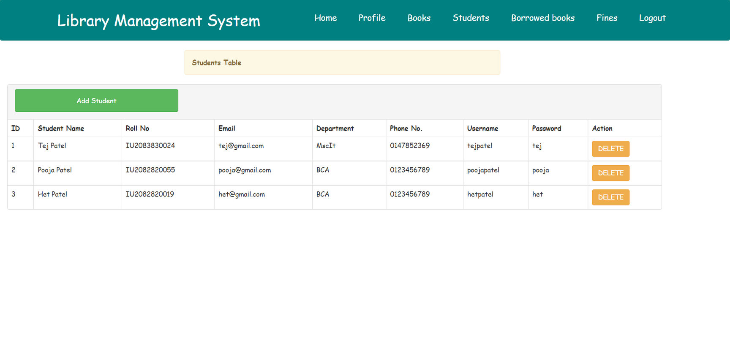

**LIBRARIAN SIDE ADD STUDENT PAGE**

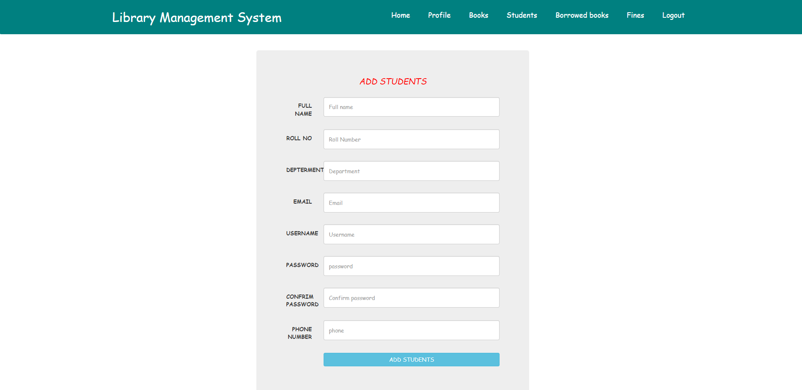

**LIBRARIAN SIDE BORROWED BOOKS PAGE**

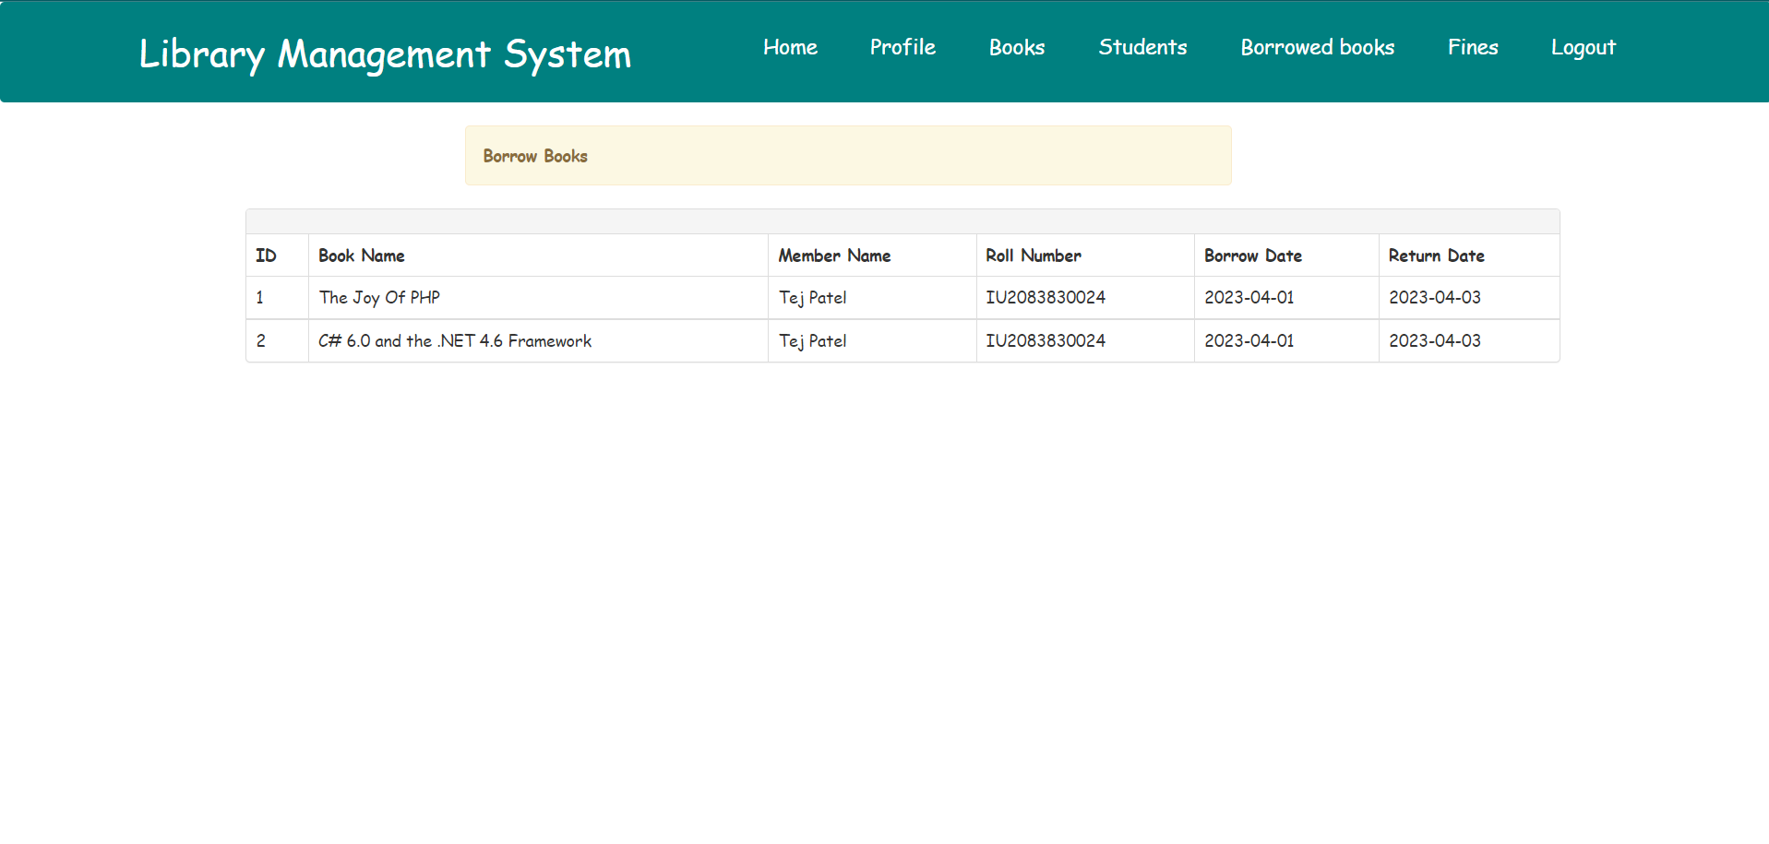

**LIBRARIAN SIDE FINES PAGE**

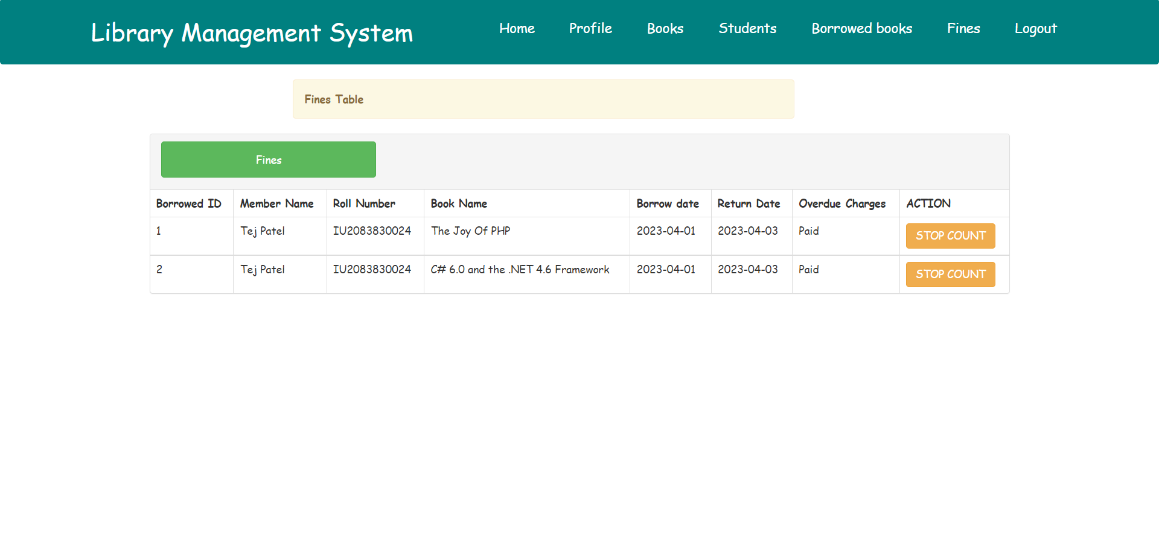

**STUDENT LOGIN PAGE**

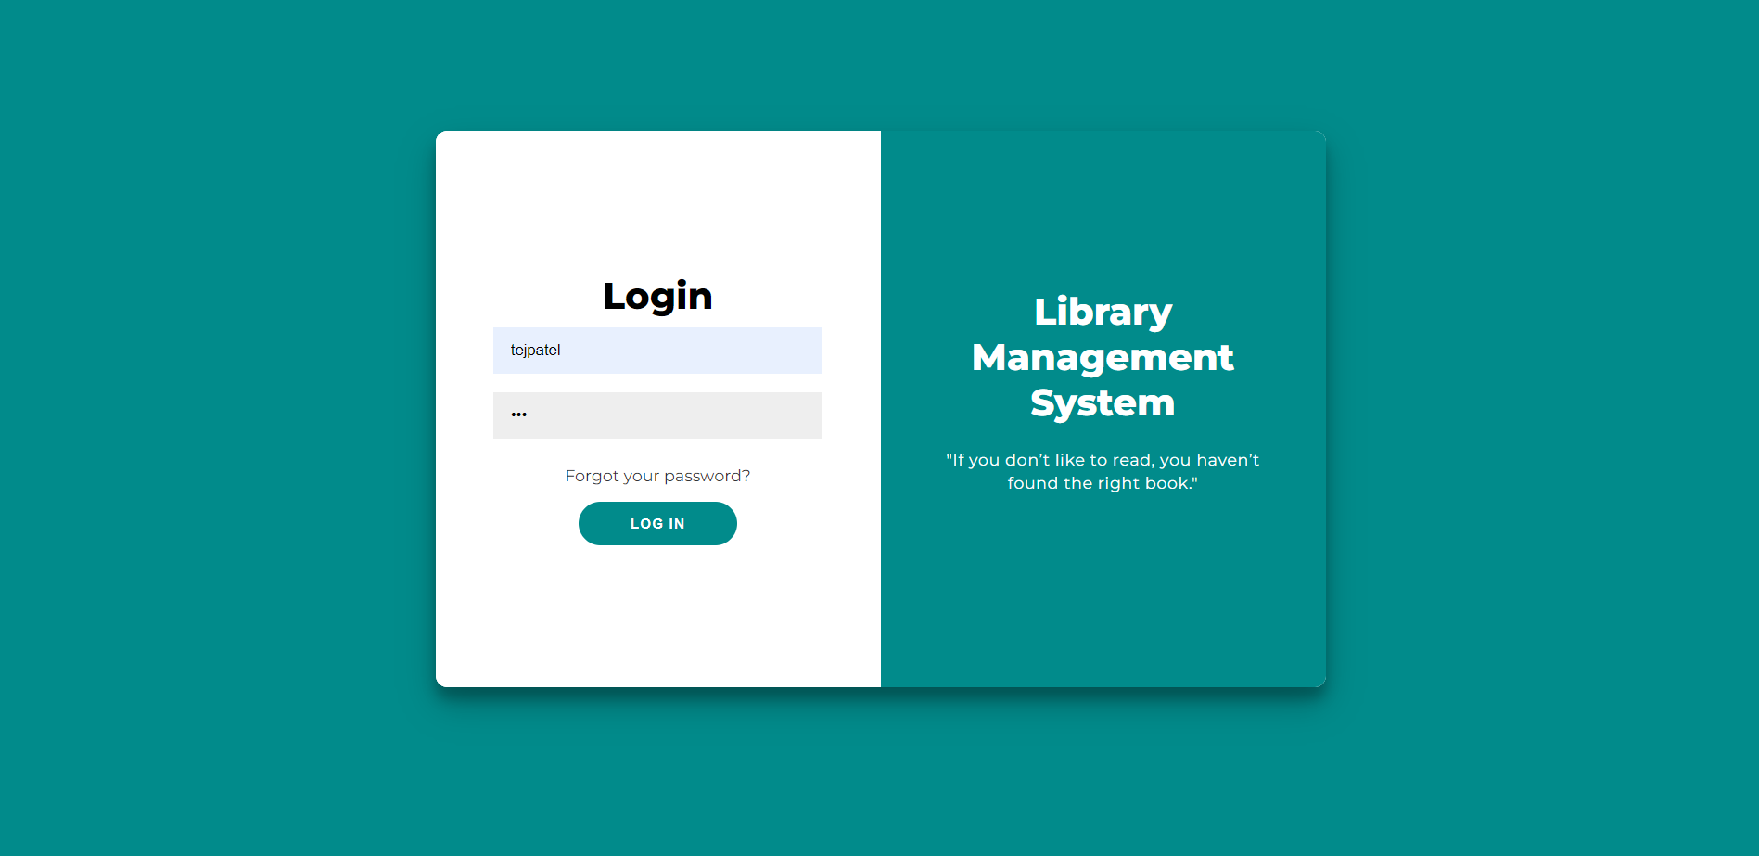

**STUDENT DASHBOARD PAGE**

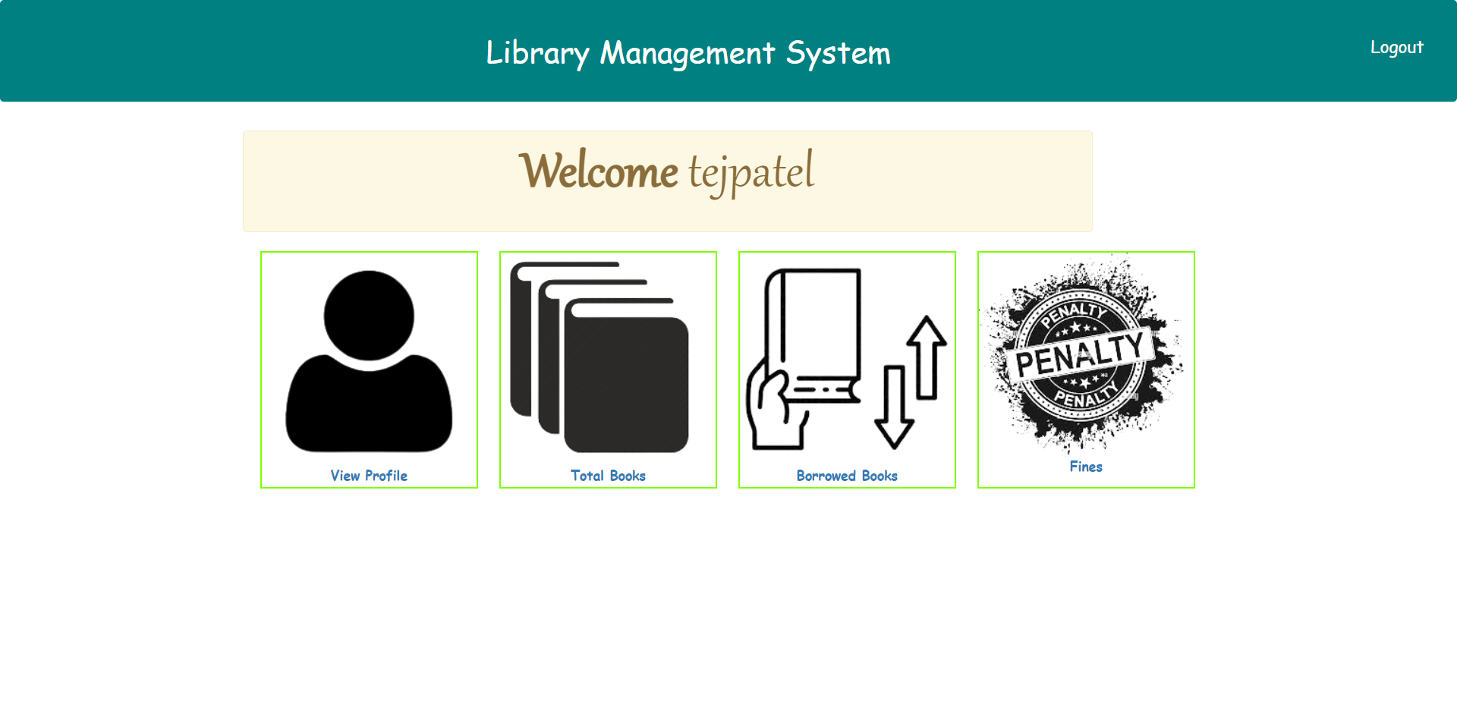

**STUDENT SIDE PROFILE PAGE**

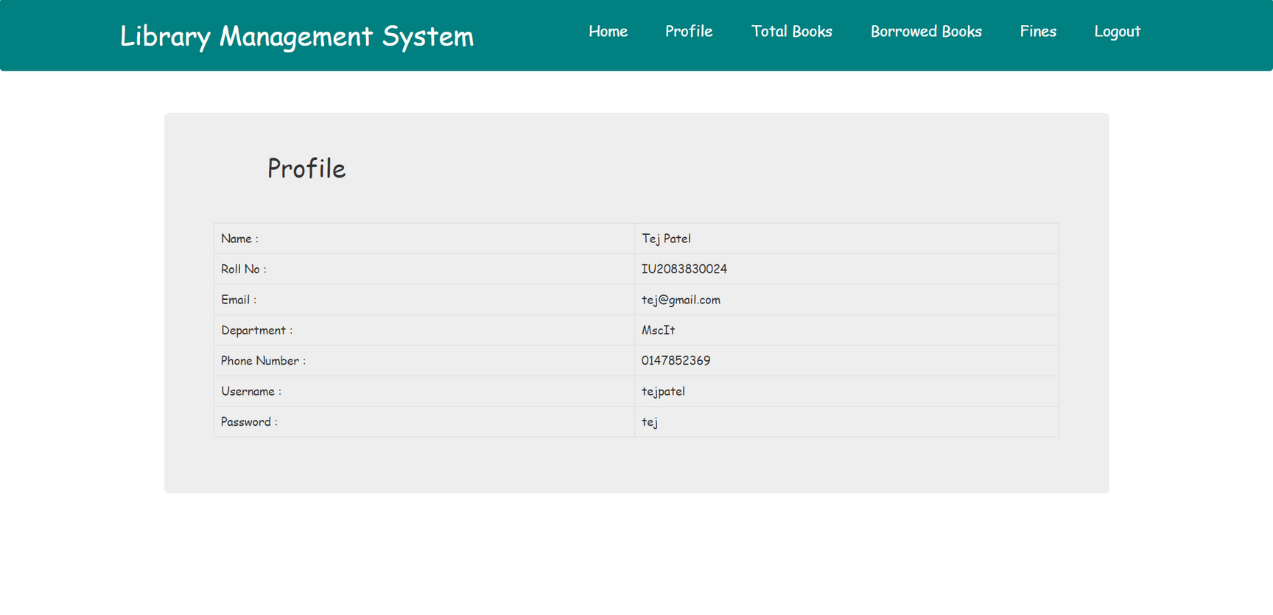

**STUDENT SIDE BOOKS PAGE**

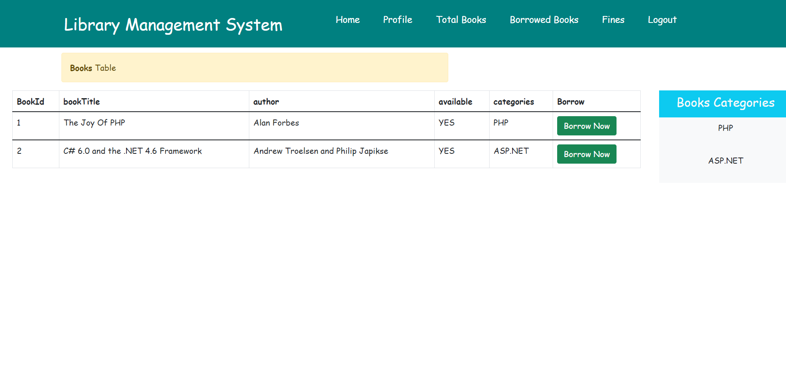

**STUDENT SIDE BORROWED BOOKS PAGE**

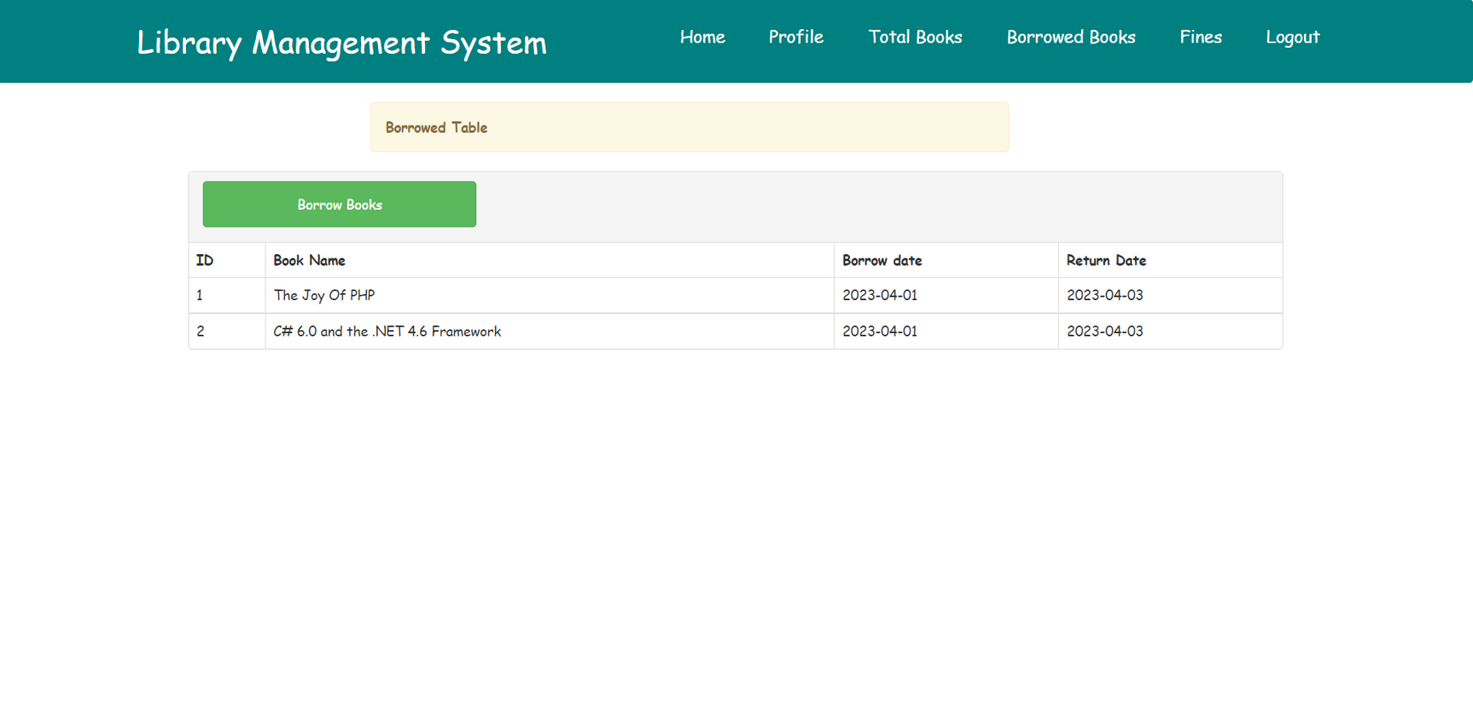

**STUDENT SIDE FINES PAGE**

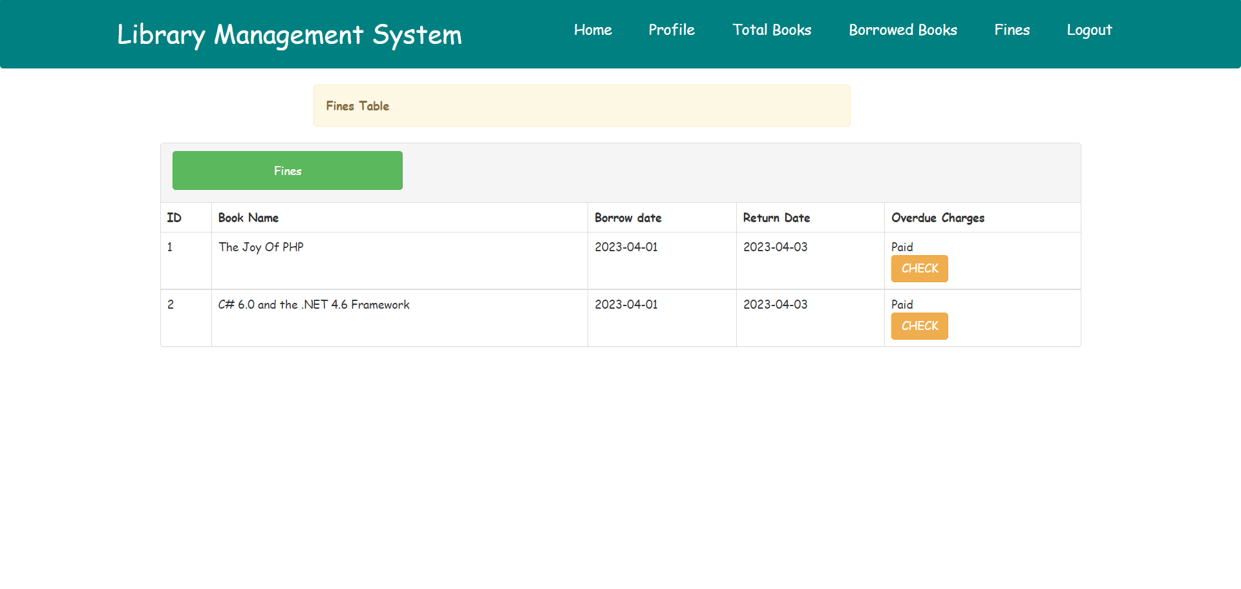

**TEST PLANS AND TEST CASES**

**Mobile Number Validation For STUDENTS Information:-**

|  |  |  |  |  |  |
| --- | --- | --- | --- | --- | --- |
| Test Case | Test Case Description | Test Steps | Test Data | Expected result | Actual result |
| A | Mobile Number to be in number | -Only number is inserted in the contact no. -10 digits required -Don’t insert Alphabet | -0-9(10) | The Form will submitted Successfully | The Form will submitted Successfully |
| B | Mobile Number to be in number | -Combination of number and alphabets are inserted in the contact no. | -0-9(A-z) | Show error message: ”Please Enter Valid Contact Number” | Show error message: ”Please Enter Valid Contact Number” |

**Email Number Validation For STUDENTS/LIBRARIAN Information:-**

|  |  |  |  |  |  |
| --- | --- | --- | --- | --- | --- |
| Test Case | Test Case Description | Test Steps | Test Data | Expected result | Actual result |
| A | Email Validation | -Enter valid Email address | Enter valid Email containing @ with domain name | The Form will submitted Successfully | The Form will submitted Successfully |
| B | Email Validation | -Enter valid Email address | Enter valid Email containing @ with domain name | Show error message: ”Please Enter Valid Email” | Show error message: ”Please Enter Valid Email” |

**PASSWORD Validation For STUDENTS/LIBRARIAN Information:-**

|  |  |  |  |  |  |
| --- | --- | --- | --- | --- | --- |
| Test Case | Test Case Description | Test Steps | Test Data | Expected result | Actual result |
| A | Password Validation | -Enter valid Password | It will validate password and confirm password | The Form will submitted Successfully | The Form will submitted Successfully |
| B | Password Validation | -Enter valid Password | password not equal to confirm password | Show error message: ”Please Enter valid Password” | Show error message: ”Please Enter Valid Password” |

**Login Page Validation For STUDENT/LIBRARIAN /ADMIN:-**

|  |  |  |  |  |  |
| --- | --- | --- | --- | --- | --- |
| Test Case | Test Case Description | Test Steps | Test Data | Expected result | Actual result |
| A | Login Data Verify | -Enter valid username -Enter valid Password - Click Login | -Enter valid Username -Valid confirm password | The page will redirect to Home page. | The page will redirect to Home page. |
| B | Login Data Verify | -Enter invalid username -Enter invalid Password - Click Login | -Enter Invalid Username or Password | Show error message: ”Wrong Username or Password” | Show error message: ” Wrong Username or Password” |

**CONCLUSION**

In conclusion, a library management system is an essential tool for modern libraries to efficiently manage their collections and provide quality services to their users.

By automating routine tasks and providing powerful tools for data analysis, these systems enable librarians to focus on more strategic initiatives and improve the overall user experience.

**FUTURE ENHANCEMENT**

The application has the potential to get a lot more features and amenities in the future. As we know with the increase in number of students, books, complexity other workloads, there can be a need of shifting the library data from the local database to the cloud. By making the appropriate adjustments, this software application can be converted to a cloud database. You can receive data backup capabilities, remote file updating and syncing, increased data security, lifetime storage, and other benefits with the aid of cloud technologies.

Will include more filter feature into the website.

* Delivery System
* Search facility for books and student
* Online fine payments

**BIBLIOGRAPHY**

With the help of below resources I have learnt so many things and applied similar logics and knowledge in my web application development process.

* + getbootstrap
  + fontawsome
  + and some youtube videos